Experiment-1
Flight Reservation System

Aim
To create a simple cloud-based Flight Reservation System using a Software as a Service (SaaS) platform to demonstrate online flight booking, passenger information management, and fare calculation.

Procedure
- Log in to a cloud SaaS platform (such as Zoho Creator, Google AppSheet, or Salesforce).
- Create a new application named Flight Reservation System.
- Design a form with the following fields:
  - Passenger Name
  - Age
  - Gender
  - Email ID
  - Phone Number
  - Departure City
  - Destination City
  - Flight Number
  - Travel Date
  - Class (Economy/Business)
  - Number of Tickets
- Add a field to display or calculate the Total Fare.
- Save the form and publish the application on the cloud.
- Enter passenger details through the online form.
- Submit the booking request.
- Verify that the booking details and total fare are stored in the cloud database.
- View the reservation details from any device connected to the internet.

Implementation:

Total_Amount = input.No_of_seats * input.Ticket_Prize;
if(input.No_of_seats <= 0)
{
alert "Please enter a valid number of seats.";
}
info "Flight booked successfully!";
if(input.No_of_seats != null && input.Ticket_Prize != null)
{
Total_Amount = input.No_of_seats * input.Ticket_Prize;
}
else
{
Total_Amount = 0;
}

Output:

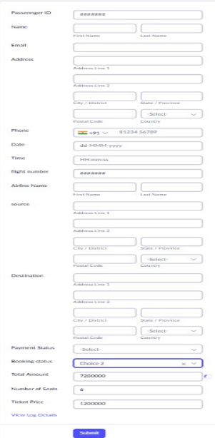

Result:
The Flight Reservation System was successfully developed and deployed using a Software as a Service (SaaS) cloud platform

